MgtOp 556—Advanced Business Modeling

Professor Munson

Topic 1

VBA Programming in Excel for
Decision Support Systems

(Set 2—Referencing Worksheets, “With” Construction, and Working with Ranges)

“The majority of operations in Excel are range operations.”

Albright, S. Christian, VBA for Modelers, 5th Ed., Cengage Learning, 2016, p. 89
Referencing Worksheets

Can refer to the “code names” of worksheets (and chart sheets).

Every worksheet has two “name” properties:
(1) Name—the name shown on the sheet tab
(2) CodeName—the name used by VBA

Set the CodeName using the “(Name)” property in the worksheet dialog box.

The following sheet has been named “Calculations” by the user (that shows up in the worksheet tab within Excel), while it has been given the CodeName “wsCalcs”.
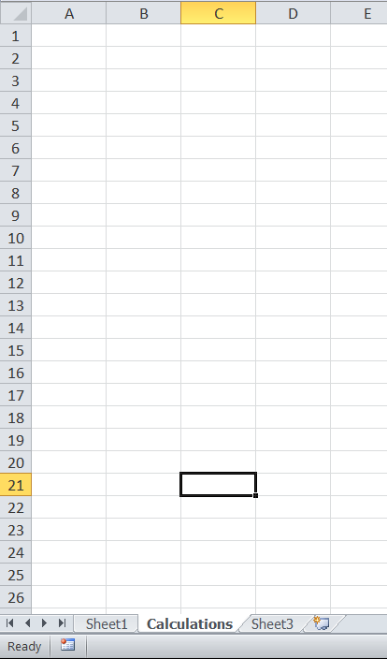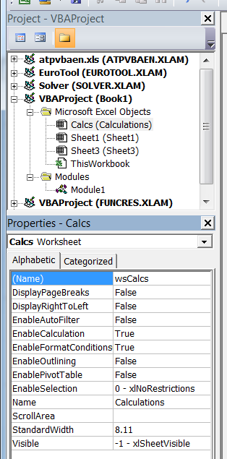
Then you can refer to Cell B6 of “Calculations” as:
wsCalcs.Range(“B6”)
Properties of Ranges

- Address: returns the address of a range as a string
Ex: Range(“B3:F7”).Address returns “B3:F7”

- Cells: refers to a specific cell in a range
Ex: Range(“B3:F7”).Cells(2,3) references cell D4
Range(“B3:B10”).Cells(4) references cell B6
Range(“B3:F3”).Cells(4) references cell E3

- Column: returns the number of the 1st column in the range
Ex: Range(“B3:F7”).Column returns 2
Range(“D3:F7”).Column returns 4

- CurrentRegion: references the smallest rectangle surrounded by blank rows and columns that contains the range
Ex:
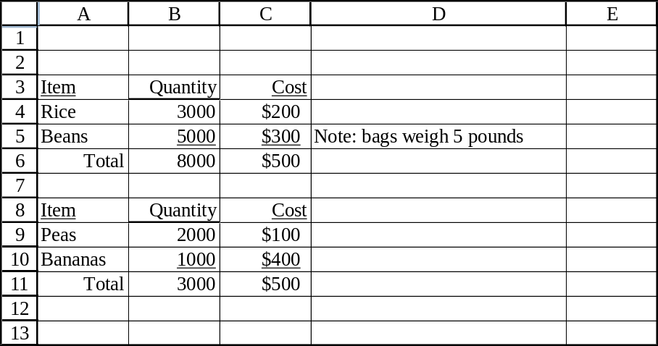
Range(“A4:A5”).CurrentRegion references A3:D6
Range(“A10:C10”).CurrentRegion references A8:C11
- EntireColumn: references the entire columns in the range (like clicking on the column labels)
Ex: Range(“B3:F7”).EntireColumn references columns B through F

- EntireRow: references the entire rows in the range (like clicking on the row labels)
Ex: Range(“B3:F7”).EntireRow references rows 3 through 7

- Font: references the font of the range—used to assign font properties
Ex: Range(“C4”).Font.Bold = True turns on bold
Range(“C4”).Font.Italic = False turns off italics
Range(“C4”).Font.Underline = True underlines
Range(“C4”).Font.Strikethrough = True applies strikethrough
Range(“C4”).Font.Name = “Arial” assigns arial font
Range(“C4”).Font.Size = 12 assigns 12-point font
Range(“C4”).Font.Subscript = True converts to subscript
Range(“C4”).Font.Superscript = False removes superscript
Range(“C4”).Font.Color = vbBlue assigns blue font
Range(“C4”).Font.ColorIndex = 5 assigns blue font

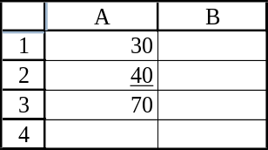
- Formula: returns the formula in the cell as a string
Ex:

Range(“A3”).Formula returns “=A1+A2”

- FormulaR1C1: returns the formula in the cell as a string in R1C1 notation
Ex:

Range(“A3”).FormulaR1C1 returns “=R[-2]C+R[-1]C”
- HorizontalAlignment: horizontal alignment of cells in the range
Ex: Range(“B3:F7”).HorizontalAlignment = xlLeft left-justifies
Range(“B3:F7”).HorizontalAlignment = xlCenter centers
Range(“B3”).HorizontalAlignment = xlRight right-justifies

- Interior: references the interior of cells in the range
Ex: Range(“B3:F7”).Interior.Color = vbYellow colors cells yellow
Range(“B3:F7”).Interior.Color = RGB(255,0,0) colors cells red
To identify RGB colors in Excel, right click a cell, then:
Format Cells…Fill:More Colors…Custom

- Name: creates a range name
Ex: Range(“B3:F7”).Name = “Data” assigns the name “Data”

- NumberFormat: specifies the number format for cells in the range
Ex: Range(“A2”).NumberFormat = “#,##0.00” formats as “, w/2 dec.”
Common Formats
Comma separator with 2 decimal places: “#,##0.00” Ex: 12,345.67
Comma separator with 0 decimal places: “#,##0” Ex: 12,346
Currency (and comma) w/ 2 decimal places: “$#,##0.00” Ex: $12,345.67
Percentage with 2 decimal places: “0.00%” Ex: 96.45%

Handling negative values
The default displays a negative value in black preceded by a minus sign
Comma with 2 decimal places for other three negative formats
Red: “#,##0.00_);[Red]#,##0.00”
Black with parenthesis: “#,##0.00_);(#,##0.00)”
Red with parenthesis: “#,##0.00_);[Red](#,##0.00)”

- Offset: provides a relative reference to a cell
Ex: Range(“B2”).Offset(3,4) refers to cell F5
Range(“B2”).Offset(0,3) refers to cell E2
Range(“B2”).Offset(-1,0) refers to cell B1
- Row: returns the number of the 1st row in the range
Ex: Range(“B3:F7”).Row returns 3
Range(“D5:F7”).Row returns 5

- Value: returns the value of the cell
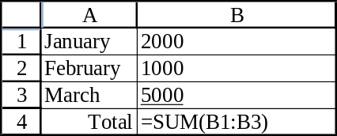
Ex:

Range(“A2”).Value returns “February”
Range(“B3”).Value returns 5000
Range(“B4”).Value returns 8000

“With” Construction

Great shortcut for setting more than one property
Must be accompanied by “End With”
Try to indent for readability

Example
Worksheets(“Sheet1”).Range(“D2”).Value = 452
Worksheets(“Sheet1”).Range(“D2”).HorizontalAlignment = xlRight
Worksheets(“Sheet1”).Range(“D2”).Font.Italic = True
Worksheets(“Sheet1”).Range(“D2”).Font.Size = 16
Can be rewritten as:
With Worksheets(“Sheet1”).Range(“D2”)
.Value = 452
.HorizontalAlignment = xlRight
With .Font
.Italic = True
.Size = 16
End With
End With
Methods of Ranges

- Clear: deletes everything—values and formatting
Ex: Range(“B3:F7”).Clear applies “clear all” to the range

- ClearContents: deletes values but retains formatting
Ex: Range(“B3”).ClearContents applies “clear contents”

- Copy: copies the range
Ex: Range(“B3:C5”).Copy Range(“F1”) copies B3:C5 to F1:G3
Range(“B3:C5”).Copy copies to the clipboard

- PasteSpecial: applies “Paste Special” from the clipboard (from something previously copied)
Ex: Range(“G1”).PasteSpecial _
Paste:=xlPasteAll
Paste:=xlPasteAllExceptBorders
Paste:= xlPasteColumnWidths
Paste:=xlPasteComments
Paste:=xlPasteFormats
Paste:=xlPasteFormulas
Paste:=xlPasteFormulasAndNumberFormats
Paste:=xlPasteValidation
Paste:=xlPasteValues
Paste:=xlPasteValuesAndNumberFormats

- Select: selects the range (also for cursor movement)
Ex: Range(“B3:G7”).Select selects (highlights) the range
Range(“V3”).Select moves the cursor to cell V3
Range(“A9”).End(xlUp).Select <End><Up Arrow> from cell A9
- Sort: sorts the range
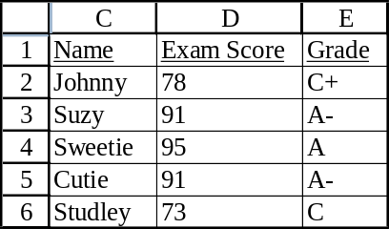
Ex:

Range(“C1:E6”).Sort Key1:=Range(“D1”), _ Order1:=xlAscending, Header:=xlYes
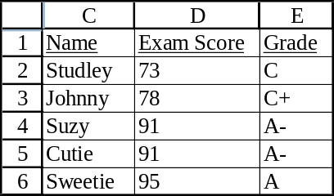

Range(“C1:E6”).Sort Key1:=Range(“D1”), _ Order1:=xlDecending, Key2:=Range(“C1”), _ Order2:=xlAscending, Header:=xlYes
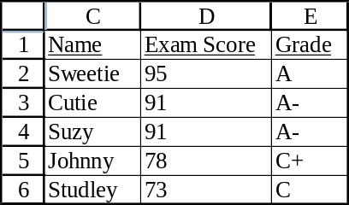

Range(“C1:E6”).Sort Key1:=Range(“D1”), _ Order1:=xlAscending, Header:=xlNo
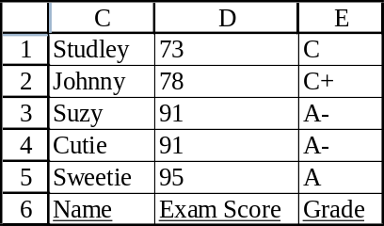

Specifying Ranges with VBA

1. Use an Address
Ex: Range(“N1”) or Range(“B6:AX123”)

2. Use a Range Name (that has been previously defined in the worksheet)
Ex: Range(“Profit”)

3. Use a Range Object Variable
Ex: Dim profitRange As Range
Set profitRange = Range(“A1:C5”)
profitRange.Font.Size = 15

4. Use the Cells Property
Ex: Range(“B3:G7”).Cells(1,2) refers to C3

5. Use the Offset Property
Ex: Range(“C6”).Offset(-3,2) refers to E3

6. Use Top Left and Bottom Right Arguments (only useful in combination with offsetting)
Ex: With Range(“A1”)
Range(.Offset(2,1), .Offset(4, 3)).Select
End With this selects the range B3:D5

7. Use the End Property (works for variable range sizes)
Ex: With Range(“A1”)
Range(.Offset(0,0), .End(xlDown).End(xlToRight)).Select
End With
Examples of Ranges with VBA
See the “Ranges.xlsm” file

Example Range2—Creating and Deleting Range Names
.Names.Add Name:=“ScoreNames”, RefersTo:=.Range(“B1:F1”)
.Names(“ScoreNames”).Delete

Example Range6—Using the End Property and the Offset Property
With a1
nScores = Range(.Offset(0,1),.End(xlToRight)).Columns.Count
nEmployees = Range(.Offset(1, 0), .End(xlDown)).Rows.Count

Example Range8—Referring to Rows and Columns
.Rows(12) refers to the 12th row of a range
.Columns(4).EntireColumn refers to the entire column corresponding to the 4th column in the range (in this case D)
.Rows(“4:5”) refers to rows 4 and 5 of a range
.Columns(“E:F”) refers to columns E and F of a range

Example Range9—Formatting Cells in a Range
.Range(“ScoreNames”).EntireColumn.AutoFit

Example Range11—Referring to Other Range Objects
Dim a1 As Range, a21 as Range, h1 as Range
Set a1 = wsData.Range(“A1”)
Set a21 = wsData.Range(“A21”)
Set h1 = wsData.Range(“H1”)
Dim UnionRange As Range
Set UnionRange = Union(a1.CurrentRegion, a21, h1)
for noncontiguous ranges

